भारतमौसमविज्ञानविभाग |  | India Meteorological Department
Friday,13th June 2025 (23 Jyeshtha 1947 Saka)
Summary of observations recorded at 0830 hours IST: The Northern Limit of Monsoon continues to pass through 17.0°N/55°E, 17.5°N/60°E, 18°N/65°E, 18.5°N/70°E, Mumbai, Ahilyanagar, Adilabad, Bhawanipatna, Puri, Sandhead Island, 23.5°N/89.5°E, Balurghat, 30°N/85°E. Conditions are favourable for further advancement of Southwest monsoon over some more parts of Vidarbha, Chhattisgarh & Odisha during next 2 days; over some parts of Gujarat, West Bengal, Jharkhand and Bihar during subsequent 3 days. An upper air cyclonic circulation lay over northwest Rajasthan at 0.9 km above m. s. l. The trough ran from the upper air cyclonic circulation over northwest Rajasthan to Marathwada across Madhya Pradesh & Vidarbha at 0.9 km above m. s. l. The upper air cyclonic circulation over north coastal Andhra Pradesh and adjoining south Odisha lay over southwest Telangana & neighbourhood today morning. It then lay over north interior Karnataka and adjoining Telangana & Rayalaseema which extended upto 5.8 km above m. s. l. titling southwestwards with height. The trough ran from north coastal Andhra Pradesh to coastal Karnataka across cyclonic circulation over southwest Telangana, interior Karnataka today morning. It then ran from westcentral Arabian Sea to south coastal Odisha across the cyclonic circulation over north interior Karnataka & adjoining Telangana & Rayalaseema and neighbourhood at 3.1 km above m. s. l. The Western Disturbance as a trough in middle tropospheric westerlies with its axis at 5.8 km above m. s. l. ran roughly along Long. 66°E to the north of Lat. 28°N. The upper air cyclonic circulation over Punjab & neighbourhood became less marked. The upper air cyclonic circulation over west Uttar Pradesh & neighbourhood became less marked. The upper air cyclonic circulation over west Rajasthan & neighbourhood became less marked.
Day temperatures were markedly above normal (> 5.1°C) at many places over Assam & Meghalaya and Jammu-Kashmir-Ladakh-Gilgit-Baltistan-Muzaffarabad; at most places over Arunachal Pradesh; at few places over east Rajasthan; at isolated places over Sub Himalayan West Bengal & Sikkim, west Uttar Pradesh, Haryana-Chandigarh-Delhi, Himachal Pradesh, west Rajasthan, west Madhya Pradesh and east Madhya Pradesh. appreciably above normal (3.1°C to 5.0°C) at many places over Nagaland, Manipur, Mizoram & Tripura and Punjab; at few places over Bihar, east Uttar Pradesh and Saurashtra & Kutch; at isolated places over Gujarat Region; above normal(1.6°C to 3.0°C) at few places over Gangetic West Bengal, Uttarakhand and coastal Karnataka; at isolated places over Odisha, Vidarbha, Tamil Nadu, Puducherry & Karaikal and Kerala & Mahe. near normal (-1.5°C to 1.5°C) at many places over Konkan & Goa, Madhya Maharashtra, Chhattisgarh, coastal Andhra Pradesh & Yanam and south interior Karnataka; at most places over Lakshadweep; at few places over Andaman & Nicobar Islands, Jharkhand, Telangana and north interior Karnataka; at isolated places over Marathwada and Rayalaseema. The highest maximum temperature of 47.8°C was reported at Sriganganagar (Rajasthan).
The Southwest Monsoon has been vigorous over coastal Karnataka and active over Konkan & Goa and north interior Karnataka. It has been subdued over Arunachal Pradesh, Assam & Meghalaya and Nagaland-Manipur-Mizoram-Tripura.
Total 305 stations reported rainfall today. Total rainfall is 206.7 cm. Total 293 stations reported rainfall today whose normals are available. Total rainfall is 196.9 cm with normal station total 197.2 cm.
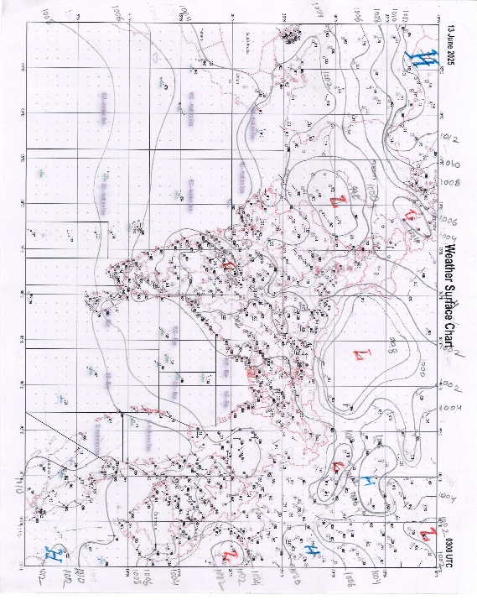 | 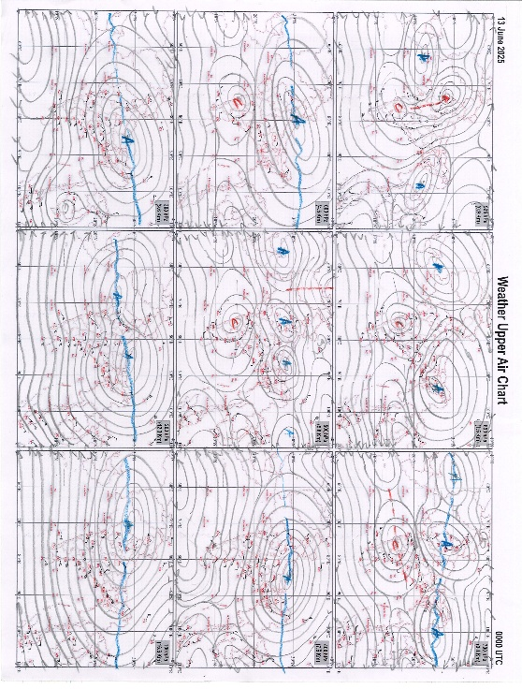
g.1. Analysed surface chart based on 03z observation | Fig.2. Analysed upper air chart based on 00z observation

Dr. S.D.Sanap
Scientist ‘D’
CR & S Office, Pune  Issued at 1245 hrs. IST |  | Weather Forecasting Division  CR&S, Pune

Indian regions | Realised rainfall (chief amount in cm during past 24 hrs):
East | a few places: Odisha  isolated places: Arunachal Pradesh, Assam & Meghalaya, Nagaland-Manipur-Mizoram-Tripura, West Bengal & Sikkim, Jharkhand and Bihar  Lengpui 4.7, Fagu tea estate 4.0, Raruana, Narsinghpur & Puraini 3.2 each, Zurrantee t.e 3.1, Saiha 2.6, Chhamonu 2.5, Baltara 2.3, Rampurhat (DRMS) 1.7, Jangipur 1.4, Jalpaiguri & Bhubaneswar AP 1.2 each, Namsai & Canning 0.8 each, Manoharpur 0.6, Tuting AWS 0.5, Dalgaon ARG, Barpathar & Dhalbhumgarh 0.3 each.
North | a few places: Uttarakhand  isolated places: Uttar Pradesh, Himachal Pradesh, Jammu-Kashmir and Ladakh and east Rajasthan  dry weather: Haryana, Punjab and west Rajasthan  Champawat 3.4, Nighasan 2.5, Narendranagar 2.3, Najibabad (t) 2.1, Baran 2.0, Kothi 1.8, Chuari 1.6, Palliakalan 1.4, Dharmsala, Govindpura AWS & Jhalarapatan SR 0.9 each, Mussoorie 0.6, Gorakhpur 0.2, Pilibhit tehsil & Gulabgarh 0.1 each.
Central | a few places: Vidarbha  isolated places: Madhya Pradesh and Chhattisgarh  Warla 3.1, Morena-aws 3.0, Khamgaon 2.3, Mehkar 2.2, Gangalur 1.2, Pachmarhi 0.8, Kuakonda 0.7, Bina 0.3, Khurai 0.2, Amraoti 0.1.
Peninsula | most places: Konkan & Goa#, Madhya Maharashtra+, coastal Karnataka# and Kerala+  many places: Marathwada and north interior Karnataka+  a few places: coastal Andhra Pradesh+, Telangana+, Rayalaseema+ and south interior Karnataka+  isolated places: Gujarat Region and Tamil Nadu+  dry weather: Saurashtra & Kutch  Rameshwar ARG 30.3, Karwar 24.2, Ponda 22.1, Devgad 22.0, Kundapur 15.6, Kota 15.3, Jadcherla 10.7, Macherla 9.8, Arakonam 9.7, Uthukottai 9.3, Bailhongal 9.1, Zalki cross 8.9, Hosdurg 8.2, Tada 7.6, Bhadravathi 7.1, Kolhapur / Karvir IMD 6.9, Tiruttani & Peringome AWS 6.7 each, Ibrahimpatnam 6.4, Sullurpeta 6.3, Kokrud 5.9, Gaganbawada & Lohara 5.7 each, Vapi 5.2, Jayapura & Kochi c.i.a.l. 4.1 each, Khanvel & Tirupati AP 3.7 each, Dharwad PTO 3.5, Davanagere PTO 3.2, Vaijapur & Adilabad 2.8 each, Parbhani 2.7, Palakoderu 2.2, Ongole 1.3, Valsad 0.2.
Islands | most places: Andaman & Nicobar  a few places: Lakshadweep  Port blair & Minicoy 5.7 each, Maya bandar 5.1, Hut bay 4.0, Amini & Agathi 0.2 each.
Table 2. Forecast / warnings (distribution of rain / thundershowers) for 7 days (valid from time of origin upto 0830 hrs IST of next day)
Sr. No |  | Sub-division Name | Day 1 | Day 2 | Day 3 | Day 4 | Day 5 | Day 6 | Day 7 | Sr. No. | Sub-division Name | Day 1 | Day 2 | Day 3 | Day 4 | Day 5 | Day 6 | Day 7
 |  |  | 13 Jun | 14 Jun | 15 Jun | 16 Jun | 17 Jun | 18 Jun | 19 Jun |  |  | 13 Jun | 14 Jun | 15 Jun | 16 Jun | 17 Jun | 18 Jun | 19 Jun
 | 1 | Andaman Nicobar Islands | W+ | W  | W  | F | F | F | F | 19 | west Madhya Pradesh | I  + | F  + | F  | F  | F  | F | W 
 | 2 | Arunachal Pradesh | S  + | F +  | F +  | F +  | W++ | W ++ | W ++  | 20 | east Madhya Pradesh | I  + | S + | W  | W+ | W+ | W | W+
 | 3 | Assam-Meghalaya | S++ | S+ | S+ | F++ | W++ | W ++ | W++ | 21 | Gujarat region | F +  | F +  | F +  | W + | W +  | F + | S +
 | 4 | Nagaland-Manipur-Mizoram-Tripura | S+ | F + | F+ | F +  | W++ | W++ | W ++  | 22 | Saurashtra and Kutch | I + | S + | F ++ | W++ | W + | F + | S +
 | 5 | Sub Himalayan West Bengal/Sikkim | F + | W++ | W+ | F | F | W + | W | 23 | Konkan and Goa | W #  | W #  | W #  | W #  | W ++  | W + | W ++
 | 6 | Gangetic West Bengal | I  | S  | F  | F  | W+ | W + | W+ | 24 | Madhya Maharashtra | F ++  | F +  | F ++  | S ++ | S ++ | S + | S ++
 | 7 | Odisha | S  | F+ | F+ | W++ | W++ | F + | F++ | 25 | Marathwada | F +  | S +  | I  | S  | F  | S | S 
 | 8 | Jharkhand | I  | S  | F  | F  | W+ | W + | W+ | 26 | Vidarbha | S  | F  | F + | W+ | W+ | W + | W+
 | 9 | Bihar | I + | I + | S  | S  | F  | F | F  | 27 | Chhattisgarh | I  | S  | F + | F+ | F + | F + | F +
 | 10 | east Uttar Pradesh | I+ | I + | S  | S  | F+ | F+ | F+ | 28 | Coastal Andhra Pradesh and Yanam | S +  | S + | S + | S+ | S  | S | I 
 | 11 | west Uttar Pradesh | I + | I+ | I  | I  | S  | S  | F  | 29 | Telangana | F +  | F + | F+ | F+ | F + | F + | F+
 | 12 | Uttarakhand | F + | F+ | F+ | W+  | W+ | W + | W+ | 30 | Rayalaseema | S +  | S  | S  | S | S  | S | I 
 | 13 | Haryana,Chandigarh and Delhi | I + | I + | I + | I  | S  | S | F | 31 | Tamil Nadu, Puducherry and Karaikal | S ++  | S # | S # | S++ | S ++ | I + | I++
 | 14 | Punjab | D+ | I + | I + | I  | I  | S | S  | 32 | Coastal Karnataka | W #  | W# | W# | W++ | W++ | W ++ | W++
 | 15 | Himachal Pradesh | I + | I + | I  | S  | S  | S | S  | 33 | North interior Karnataka | W++ | F++ | S+ | S+ | F+ | S | I +
 | 16 | Jammu-Kashmir and Ladakh | I  + | I  + | I  | S  | I  | D  | D  | 34 | South interior Karnataka | F #  | F# | F++ | F++ | W++ | S + | I ++
 | 17 | west Rajasthan | I  + | I + | I + | I | I | I  | I | 35 | Kerala and Mahe | W++ | W++ | W# | W# | W #  | W ++ | W #
 | 18 | east Rajasthan | I + | I + | I | I  | I | I  | S  | 36 | Lakshadweep | W  | W  | W  | W  | W  | W | W
Legends: D = Dry I = Isolated S = Scattered F = Fairly widespread W = Widespread #= heavy to very heavy rain at a few places with extremely heavy rain at isolated places +++= heavy rain at a few places with very heavy rain at Isolated places ++= heavy to very heavy rainfall @=Isolated exceptionally heavy rainfall + = heavy rain ●/*= rain or snow ♦ = very light rain ≡=fog= thunderstorm with lightning =Squall / Gusty / gale / strong wind ­ =cold wave/cold day += heat wave/warm night/hot and humid weathe r=Duststorm =ground frost = Hail
Fig. 4: Districtwise warnings for five days for Maharashtra State
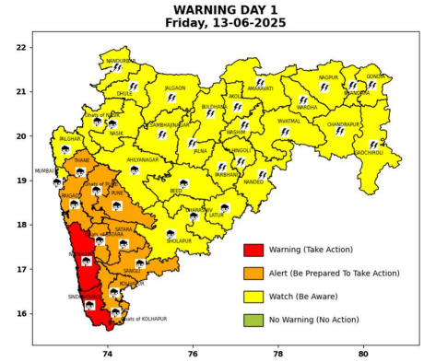 | 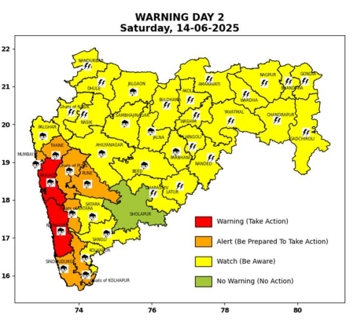 | 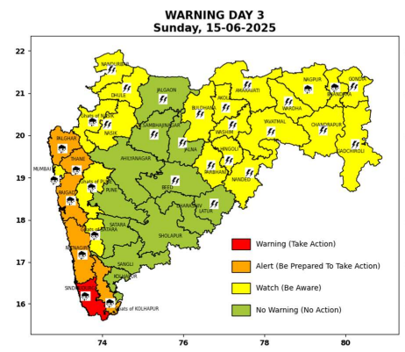 | 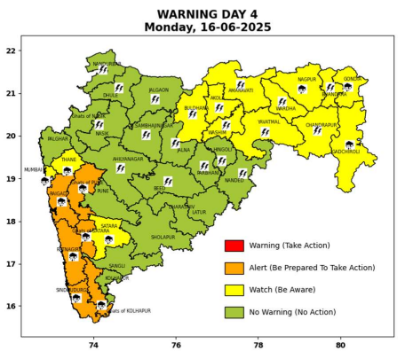 | 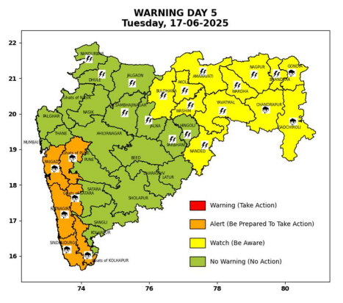

Pune, Lohegaon and Pashan observations at 0830 hrs. IST of Today
 | Temperature (°C) |  |  |  |  | Humidity (%) |  |  |  | Rainfall (mm)
 | Max.  past  24 hrs | Dep.  from  normal | Min.  past  24 hrs. | Dep.  from  normal | Dry  Bulb | At 0830 hrs. IST | Dep.  From  normal | At 1730  hrs. IST of y’day | Dep.  from  normal | Past  24 hrs. | Since  1st June | Dep.  from  normal
PNE | 31.0 | -1.4 | 21.3 | -2.0 | 24.0 | 90 | 13 | 69 | 3 | 25.8 | 69.2 | 2.8
PSN | 29.9 | - | 20.6 | - | 23.2 | 100 | - | 74 | - | 39.2 | 70.7 | -
LHG | 32.8 | -0.2 | 23.5 | 2.5 | 25.8 | 81 | 7 | 60 | 1 | 22.8 | 84.6 | 37.7

 |  |  |  |  |  |  | Local (Pune and neighbourhood) forecast
Max./Min. Temperature (°C) |  |  |  |  |  |  |  |  | Weather
Date | Pune | Pashan | Lohegaon | Chinchwad | Lavale | Magarpatta | NDA | Koregoan Park
13/06/25 | 30/21.3* | 29/20.6* | 31/23.5* | 31/22.3* | 30/21.8* | 31/22.6* | 30/21.5* | 31/23.3* | Generally cloudy sky. Light to moderate rain very likely.
14/06/25 | 30/21 | 29/21 | 31/23 | 31/22 | 30/22 | 31/23 | 30/21 | 31/23 | Generally cloudy sky. Light to moderate rain very likely.
15/06/25 | 31/22 | 30/22 | 32/24 | 32/23 | 31/23 | 32/24 | 31/22 | 32/24 | Generally cloudy sky. Light to moderate rain very likely.
16/06/25 | 31/22 | 30/22 | 32/24 | 32/23 | 31/23 | 32/24 | 31/22 | 32/24 | Generally cloudy sky. Light rain likely.
17/06/25 | 31/23 | 30/23 | 32/25 | 32/24 | 31/24 | 32/25 | 31/23 | 32/25 | Generally cloudy sky. Light rain likely.
18/06/25 | 32/23 | 31/23 | 31/25 | 33/24 | 32/24 | 32/25 | 32/23 | 33/25 | Generally cloudy sky. Light rain likely.
19/06/25 | 32/23 | 31/23 | 31/25 | 33/24 | 32/24 | 32/25 | 32/23 | 33/25 | Generally cloudy sky. Light rain likely.
Rainfall Distribution |  |  | Rainfall Categories | Rainfall (mm) |  | Cloud condition |  |  |  | Rainfall Intensity |  | Range
Widespread (W) | 76-100% |  | Very Light rain | Trace to 2.4 mm |  | Mainly clear sky |  | 1-2 oktas |  | Light Spell |  | 1 cm/hr
 |  |  | Light rain | 2.5 to 15.5 mm |  | Partly cloudy sky |  | 3-4 oktas |  | Moderate Spell |  | 1-2 cm/hr
Fairly Widespread (FW) | 51 – 75% |  | Moderate rain | 15.6 to 64.4 mm |  | Generally cloudy sky |  | 5-7 oktas |  | Intense Spell |  | 2-3 cm/hr
Scattered (S) | 26 – 50% |  | Heavy rain | 64.5 to 115.5 mm |  | Overcast |  | 8 oktas |  | Very Intense Spell |  | 3-5 cm/hr
isolated (I) | 1 – 25% |  | Very heavy rain | 115.6 to 204.4 mm |  |  |  |  |  | Extremely Intense Spell |  | 5-10 cm/hr
D (D) | No Rain |  | Extremely heavy rain | ≥ 204.5 mm |  |  |  |  |  | Cloudburst |  | > 10 cm/hr
Probability Terms in %: |  |  | Heavy snow | 6.5 to 11.5 cms water equivalent of rain
unlikely | < 25 |  | Very heavy snow | 11.6 to 20.4 cms water equivalent of rain
likely | between 25 50
very likely | between 51 75
most likely | >75
* = realized temperature
Mumbai (Colaba) |  |  |  | Nagpur (AP)
Date 2025 | T max °C | T min °C | Weather | T max °C | T min °C | Weather
13/06 | 30 | 25 | Generally cloudy sky with Heavy rain. | 39 | 27 | Rain or thundershowers accompanied with lightning & gusty winds(40-50kmph).
14/06 | 31 | 25 | Generally cloudy sky with Heavy rain. | 40 | 25 | Rain or thundershowers accompanied with lightning & gusty winds(50-60kmph).
15/06 | 31 | 25 | Generally cloudy sky with Heavy rain. | 40 | 24 | Heavy rain or thundershowers accompanied with lightning & gusty winds(40-50kmph).
16/06 | 31 | 24 | Generally cloudy sky with Heavy rain. | 40 | 24 | Rain or thundershowers accompanied with lightning & gusty winds(40-50kmph).
17/06 | 30 | 24 | Generally cloudy sky with intermittent rain. | 40 | 23 | Partly cloudy sky with thundery development.
18/06 | 31 | 23 | Rain. | 39 | 23 | Partly cloudy sky with thundery development.
19/06 | 31 | 23 | Rain. | 39 | 23 | Partly cloudy sky with thundery development.

